Second toe longer than your first toe? Take a better B complex. 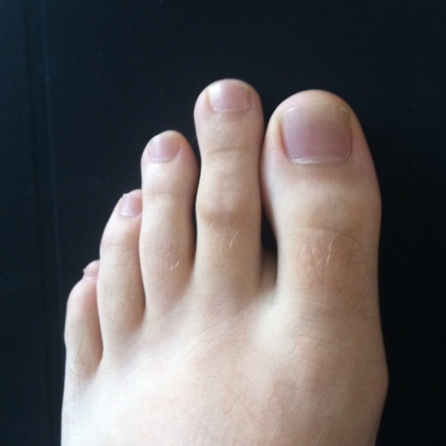

If your first, big, toe is shorter than your second toe (more specifically: if the crease between toes 1 and 2 is deeper than the crease between toes 2 and 3), you may have something called Morton’s foot or Morton’s toe. This can cause several physical problems relating to posture and ergonomics such as back pain, hip pain, knee pain, arthritis, bunions, and fibromyalgia.

In addition to the physical aspects, interesting research shows that people with Morton’s toe may also have an inability to make the active form of vitamin B6.

Vitamin B6 an extremely important vitamin, required for the proper functioning of at least 60 different enzymes. Important in the multiplication of all cells, it is of critical importance in pregnancy, mucous membrane health, skin and immune system. It is used in the production of neurotransmitters responsible for proper functioning of the brain (there important for depression). It also helps in the making of hemoglobin that carries oxygen throughout our bodies (anemia). It is essential for the conversion of food into glucose, which is then used to produce energy (metabolism). It is also essential for the breakdown of a toxic amino acid called homocysteine that is associated with heart disease.

There are many studies showing that vitamin B6 helps in the treatment of:

asthma

autism

cardiovascular disease

carpal tunnel syndrome

Chinese restaurant syndrome (MSG breakdown)

depression

diabetes

epilepsy

immune enhancement

kidney stones

nausea and vomiting during pregnancy

osteoporosis

premenstrual syndrome

and many more

In order to utilize vitamin B6 (pyridoxine), the body phosphorylates (changes) the B6 to the active form: pyridoxal 5’ phosphate (p5p). It is this active form that is used by the body, and people with a longer 2’nd toe seem to be missing the ability to change the regular B6 to the active p5p, and therefore have a functional deficiency of p5p.

The exciting thing is that this problem can easily be screened by looking at your toes. And there are some wonderful B complex vitamins that contain the active form of B6, along with B12, folic acid and other nutrients necessary for proper pyridoxal 5 phosphate formation and utilization. Advanced B Complex by AOR and Pyridoxal 5’- Phosphate by Throne are two good quality brands that are reasonably priced and available in Mississauga at our Noumena Naturopathic clinic, or at Nature’s Source, Hoopers, or Village Pharmacy.

references:

http://www.ncbi.nlm.nih.gov/pubmed/25441836

<http://www.nutri-facts.org/eng/vitamins/vitamin-b6-pyridoxine/at-a-glance/>

Murray, M. Encyclopedia of Natural Supplements. Prima Communications. p100-110.